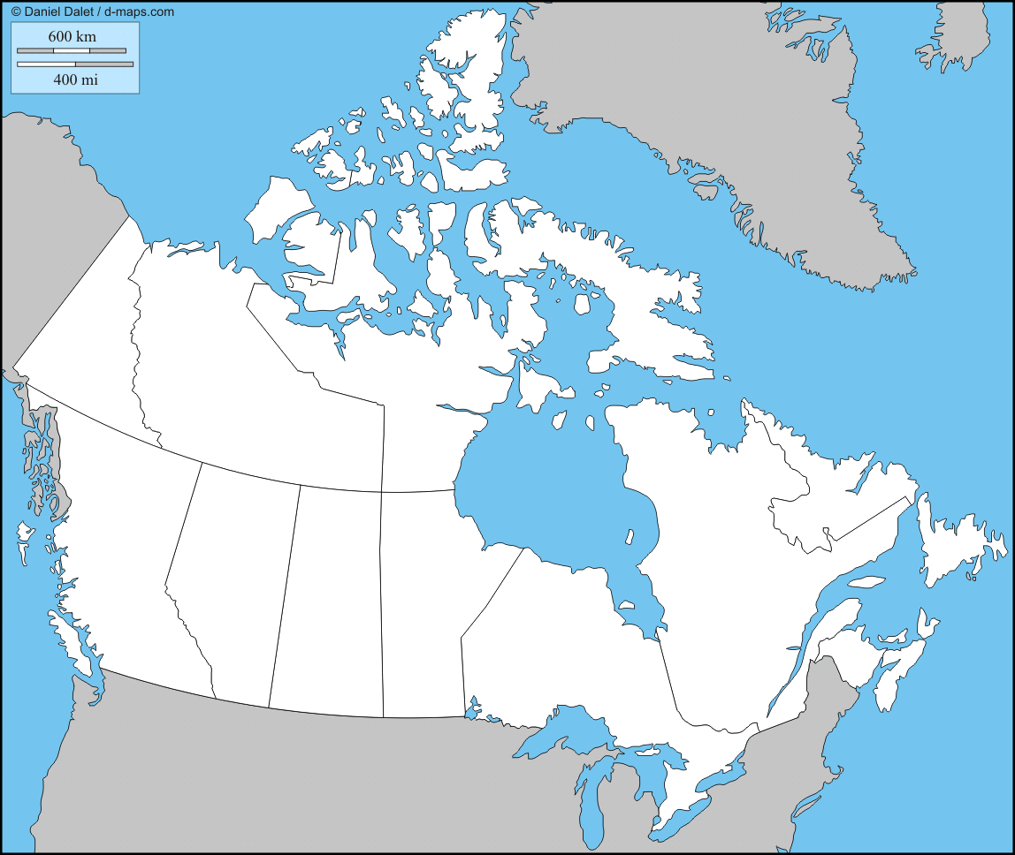
Victoria Edmonton Regina Winnipeg
Toronto Québec Fredericton Halifax
Charlottetown St. John’s Yellowknife Whitehorse
Iqaluit Ottawa (capitale du Canada)

